Cody Competition Guide

This guide will give you an overview of how to run a Cody competition. Read through this entire document before you move on to other files in this folder.

# Overview

A Cody competition is a 2-week event in which students compete to solve the most MATLAB problems in a problem group. The problems in these groups are chosen to engage students with various MATLAB experiences. Participants are ranked on a leaderboard based on the number of problems they solve correctly and the efficiency of their code.

# Leaderboard

A guide on setting up the leaderboard can be found in the file titled ‘Setting up Cody Leaderboard’ As an overview, the code for the leaderboard is set up to do 3 main things:

1. **Rank players based on the number of problems solved and then on solution size**. To avoid ties in participants who solve the same number of problems the total solution size across.
2. **Output a leaderboard file**. Your job will be to update the participants of the rankings. To keep the participants engaged and compete, post the leaderboard every few days.

# Promoting the Competition

As with all events, the key to having a successful turnout is to promote early and to as many students as possible. Unlike other events, however, there are no barriers to participating in this competition. Because of this, you must promote to as many different groups on campus as possible. The following files are included in the folder to help you promote the competition.

* **3_Poster Sample.pptx** – A poster explaining the competition
* **4_Email Template.docx** – An email invite explaining the competition and how to participate
* **5_Reminder_Email Template.docx** – An email reminding student that the competition is going on and the current rankings
* **6_Social media flyer.pptx** – Smaller banner image intended to generate interest for the competition on social media

# Organize Cody

* Create a Google/Microsoft form for registration.  
   Important fields in the form required later to create leaderboard:
  + - Name of student/participant
    - Player ID

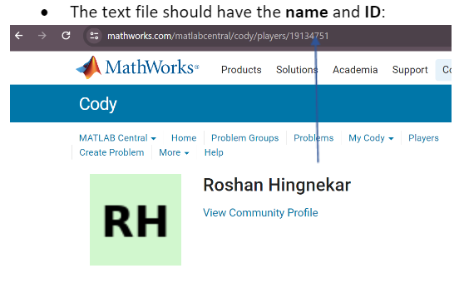

# Problem Groups

For the competition use one of the problem groups. **Explore the Cody page for more** [**playlists.**](https://www.mathworks.com/matlabcentral/cody/groups)

One of the popular playlists is below:

|  |  |  |  |
| --- | --- | --- | --- |
| Problem Group | Description | Topics | Group ID |
| [MATLAB Competition 1](https://www.mathworks.com/matlabcentral/cody/groups/2808) | Covers the basics of MATLAB and some questions at the end to test your skills. | MATLAB basics, vectors, matrices, indexing, strings, computational geometry | 2808 |

The competition should be advertised to all students on your campus. To participate, they simply use the link to the problem group and start solving problems. Participants must solve the problems while in the problem group. If they leave the problem group and solve a problem, it will not count towards their score. When solving problems for the group, you will see them on the right of the page (picture below).

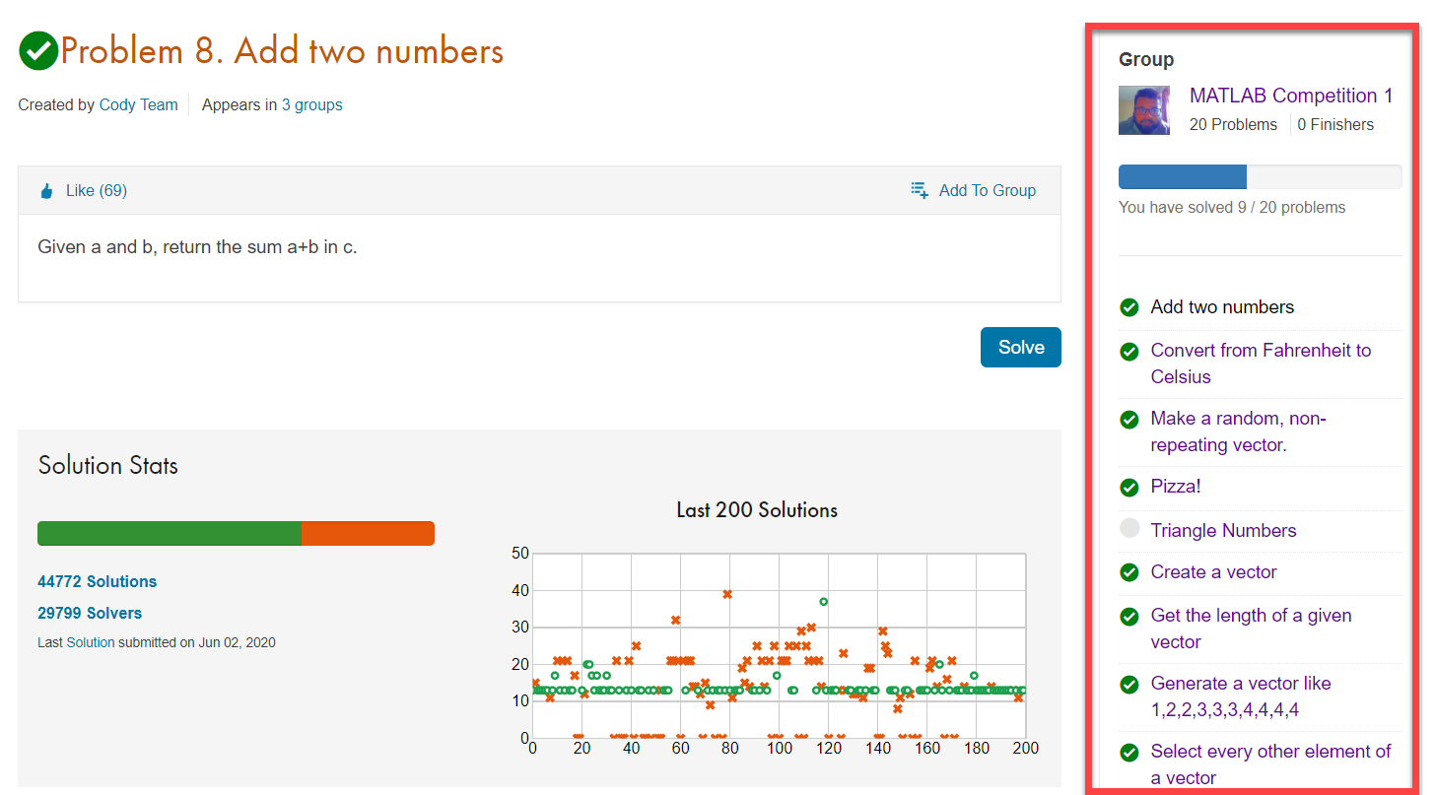

Problems must also be solved within the timeline of the competition. While their account may show that they solved the problem, the leaderboard code only counts solutions submitted during the specified start and end date of the competition.

# Timeline

|  |  |  |
| --- | --- | --- |
| When | Description | Actions |
| 4 weeks before | Start planning the logistics for the competition. Share the registration form | * Decide dates for competition |
| 3 weeks before | Test the leaderboard code to ensure it’s working for your university domain. | * Test setting up the leaderboard code * Solve a few problems and see how it appears on the leaderboard |
| 2 weeks before | Begin advertising! To increase the number of participants, advertise early and advertise to everyone. | * Share the competition dates * Inform professors about this competition |
| 1 week before | Set up leaderboard | * Use Setting up Cody Leaderboard.docx to set up the leaderboard |
| During | Share the leaderboard with your social media group every couple of days. Encourage people to keep participating | * Post Leaderboard frequently continue promoting competitions * Encourage students to keep solving problems |
| Last day of competition | Once the competition ends, no more entries will be considered. Use the leaderboard to decide winners. | * Announce the winners and thank everyone for participating |
| 1 Week after | Set up time to give out prizes. It’s suggested that you set up time slots on 2 different days. | * Hand out prizes |

Feel free to connect with Roshan Hingnekar ([rhingnek@mathworks.com](mailto:rhingnek@mathworks.com)) for any queries.

# Prizes

To keep students motivated to win this competition, we recommend giving prizes to the winners. It is up to you, however, to consider if/what prizes should be given for your competition. Be sure to consider whether you can logistically give out giveaways, the number of participants, and what giveaways you currently have. For example, you could give a T-shirt to the top 5 winners. But if you have over 100 participants maybe you give a T-shirt to the top 5 and a hat to the top 10. If you need more giveaways, be sure to ask for more before the start of the competition.